“Sing, Darlin’!”
-Vestal Goodman,
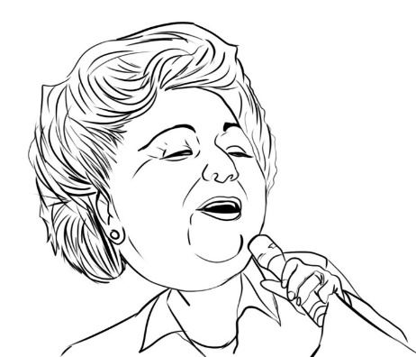
The Happy Goodman Family

“Every time they ask you,” she said, “Don’t give them a chance to ask you a second time. If they really didn’t want you to sing, they had no business asking.”

I’m sure she spoke those words more than once, but this time she had just taken the stage for an evening concert at the Stamps-Baxter School of Music and was asked what advice she would give to aspiring singers. She went on to explain that she ALWAYS had something ready if asked. It might mean keeping a favorite track on hand or just being ready to belt out a captivating a cappella piece.

I’ve always remembered those words and worked to stay prepared. There’s a similar saying that success is where preparation meets opportunity. There’s a lot of talent out there that goes undiscovered, and there is a lot to be said for who you know. Even so, you increase your chances at success if you are prepared. Don’t give them a chance to change their minds and go another direction. When the door opens, you’re ready to go through it with confidence.

“If you’re going to make a mistake, make a daggone good one and recover!”
-Ron Rose,
John Marshall High School
Band Director

We heard this one frequently in Ron Rose’s band room, and it was absolutely freeing. We had permission to make a mistake! It was bound to happen as we tried to hit that hard run or high note. With that permission, we could stretch our abilities. We could reach further than we normally dared in order to see what we could and couldn’t do. And when we stretched beyond our means, we had a plan: jump in on the next note or phrase, and keep going. Don’t let one mistake turn into two or three. And don’t just tootle-loo a mistake because you are only half- trying. No, honk it out and move on.

We found out that, more often than not, we could reach that note or play that run. When one got away from us, it was okay because we had far more success than failure and we didn’t just fall off and pout about it. We finished strong.

I have played this one over and over again in the course of my life. Go big. Dream big. Stretch to reach it. But if (when) you make a mistake, shake it off and jump right back in there with the next measure of life.

